Nutrition Consult Request Form©
Nutrition Support Service Veterinary Medical Teaching Hospital
One Shields Ave, Davis, CA 95616-8747
Ph: 530-752-7892
Email: nssvetmed@ucdavis.edu
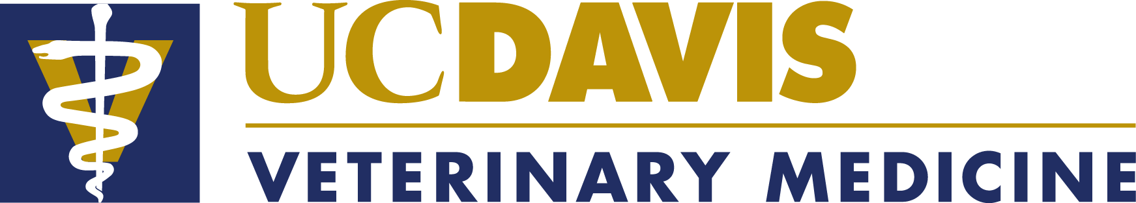

DVM:
Clinic:
Address:
Phone: Email : Date:
We require the following to proceed with the consult: (Please check)

Nutrition Consult Request Form – Completed by DVM Included
Diet History Form – Completed by owner Included
Complete Blood Count Included
Serum Chemistry Panel (inc. T4 if indicated) Included
Urinalysis Included
Other relevant medical records as necessary (UPC & BP for pets with CKD, biopsy and imaging results for pets with gastrointestinal or hepatic disease, etc.) Included

**********Please ensure all labwork is current (within the last 6 months)**********

Reason for request: (Please check one or more)
Balance current home-cooked diet (Please attach a list of ingredients with amounts fed daily)
Formulate home-cooked diet, because no commercial diet available to meet pet’s needs
Pet finds commercial diets unpalatable
Other, please specify:

Please note if the request is urgent (additional fee will apply)
May we contact the owner directly with questions if needed? Yes No
Owner name: Pet name:
Species: Age: Breed: Sex: M, MC, F, FS (circle one)
Muscle Condition Score: Normal, Mild loss, Moderate loss, Severe loss (circle one)

Body Condition Score (9 point scale): (Dogs: 4 to 5 is ideal; Cats: 5 is ideal)

Body weight: Current: Ideal: (Please indicate kg or lb)
Current medical problems: (Attach additional sheet if necessary)

Does the pet have a good appetite? Typically: Yes No Currently: Yes No

Has the pet been weight-stable? Historically: Yes No Currently: Yes No

Previous medical history: (Please include dates)

Other considerations: (Attach additional sheet if necessary)

Current medications: (Attach additional sheet if necessary)

Please read the FAQ and review the recipe template on our website prior to submitting this consult request.
Thank you for your request. We will contact you with follow-up questions as needed.
Customized home-cooked recipe formulation is $461, which is charged when the request is submitted ($228 for the Nutritional Assessment (nonrefundable) and $233 for the diet formulation). This includes up to 30 minutes of follow up.
Additional follow-up is $108 per 30 minutes; this includes review of medical records as well as communications.
If the initial diet formulation is not tolerated or palatable, one recipe reformulation can be provided at no charge if requested within 6 months of the initial formulation. Other diet reformulations and additional recipes are $293 each if requested within 6 months of the initial formulation. Calorie adjustments are always provided at no charge.
Prices are current as of July 1, 2023, but are subject to change. An invoice will be sent directly to your clinic by the VMTH Cashier’s Office. Please do not send payment prior to receiving the invoice.

