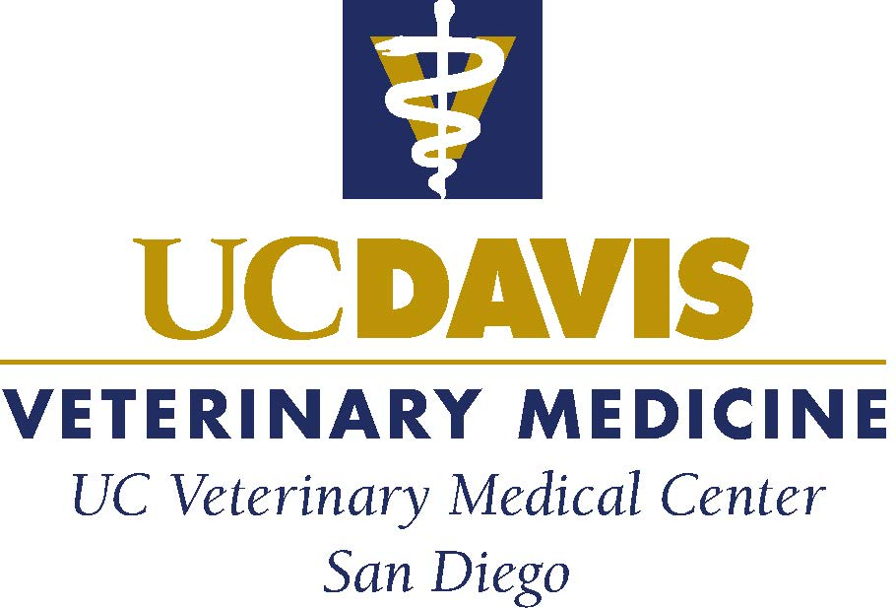

CLINICAL FELLOWSHIP IN URINARY DISEASE & EXTRACORPOREAL THERAPIES AT THE UNIVERSITY OF CALIFORNIA VETERINARY MEDICAL CENTER-SAN DIEGO (UCVMC-SD)

This two-year program is designed to provide advanced specialty training in clinical nephrology, lower urinary tract disease, and advanced applications of extracorporeal therapies. The position will provide didactic and clinical training in the basic science, pathophysiology, diagnosis and management of lower urinary tract diseases, acute and chronic diseases of the kidney, critical patient care, urinary imaging, and endourology. Emphasis will be placed on the principles and veterinary applications of intermittent and continuous hemodialysis, hemoperfusion, and therapeutic apheresis including, plasma exchange, cytapheresis, and plasma adsorption on state-of-the-art extracorporeal platforms. Clinic responsibilities include consultation and management of outpatient and hospitalized animals referred to the UCVMC-SD for urinary disease and extracorporeal therapies. There is expectation to participate in the teaching and research activities of the UCVMC-SD and the Hemodialysis and Extracorporeal Therapies service at UC Davis. This program also provides opportunity for ACVNU residency training.

Minimum Qualifications:

- Doctor of Veterinary Medicine or equivalent degree.
- Board certification in Small Animal Internal Medicine or Veterinary Emergency and Critical Care (preferred).
- University Veterinary License or Full Veterinary License from the State of California.
- Practice experience in a residency program or specialty hospital practicing high quality medicine.

To view the position and to apply online, visit:

https://careerspub.universityofcalifornia.edu/psp/ucdavis/EMPLOYEE/HRMS/c/HRS_HRAM.HRS_APP_SCHJOB.GBL?Page=HRS_APP_JBPST&JobOpeningId=61702&PostingSeq=1&SiteId=7&languageCd=ENG&FOCUS=Applicant For further information, please contact Martin Durham (858-875-7505 or mwdurham@ucdavis.edu) or Dr. Larry D. Cowgill (530-752-6543 or ldcowgill@ucdavis.edu). UC Davis and the UCVMC-SD are interested in candidates who are committed to the highest standards of scholarship and professional activities, and to the development of a campus climate that supports equality and diversity.

