UC Davis School of Veterinary Medicine: Office for Global Programs
First Steps:
A guide to explore veterinary educational opportunities abroad

At this point in time, you have probably heard a little bit about the international opportunities afforded to you through the UC Davis School of Veterinary Medicine. Whether this was through emails, friends who have done it previously, or through our presentations at Global Programs Day and the Research Round-up, you might be thinking – where do I even begin? It may seem daunting at first, but this guide is here to help you in the process.

Where to Begin?

Brainstorm
A good first step is to ruminate on any current ideas you have related to going abroad. Is there a particular country you have always wanted to visit, but have never had the chance? Or alternatively, is there a specific type of research you want to do with a specific professor, or type of clinical work you would like to pursue? It is good to have an idea of at least one of these things, but if you don’t know, it’s alright! There are a few ways you can get some ideas.

Do some research!

General Info: The Office for Global Programs website is a wealth of information and will be referred to several times in this article. Start to peruse it to learn more: https://www.vetmed.ucdavis.edu/global-programs

Faculty Engaged Globally and Who Shares Your Interests: If you have an idea of where you would like to go, you can look at the faculty engagement page on the Office for Global Programs website https://www.vetmed.ucdavis.edu/global-programs/faculty-staff. We are updating this map and encouraging our SVM faculty to submit their interests and engagement to the Global Affairs Global Connections Database. You can use the search function on this database to find our faculty, and faculty throughout the campus who are working internationally: https://ucdavis.moveonca.com/publisher/1/eng. Also go to the SVM faculty directory and search for faculty by name or by focus (interest/expertise): https://www.vetmed.ucdavis.edu/faculty_directory. When you ‘View Listing’ or click on the faculty member’s name you will go to their webpage where most faculty have a ‘Research Profile’ where you can learn more about their research activities. If you go to ‘Network’ and then to ‘Map’, you can see all the countries and institutions in the world where that faculty has research collaborations.

Previous Students: Look at videos of what previous students have done abroad and see if anything inspires you (example below)! Whether that be the country they visited, or the type of work they did. Check-out the short (2-3 min) videos and reports by students who traveled globally with funded projects and activities from 2015-2019: https://www.vetmed.ucdavis.edu/global-programs/students. The COVID-19 pandemic resulted in international travel restrictions in 2020. However, on the website you can see the remote and/or domestic projects that five of the fifteen student who were funded were able to conduct. We encourage you to plan a global project/externship for 2021 and apply for funding. If pandemic travel restrictions persist you could still accept your funding if you can propose an alternative (Plan B) project. Discuss this with Associate Dean Conrad when you meet by Zoom.
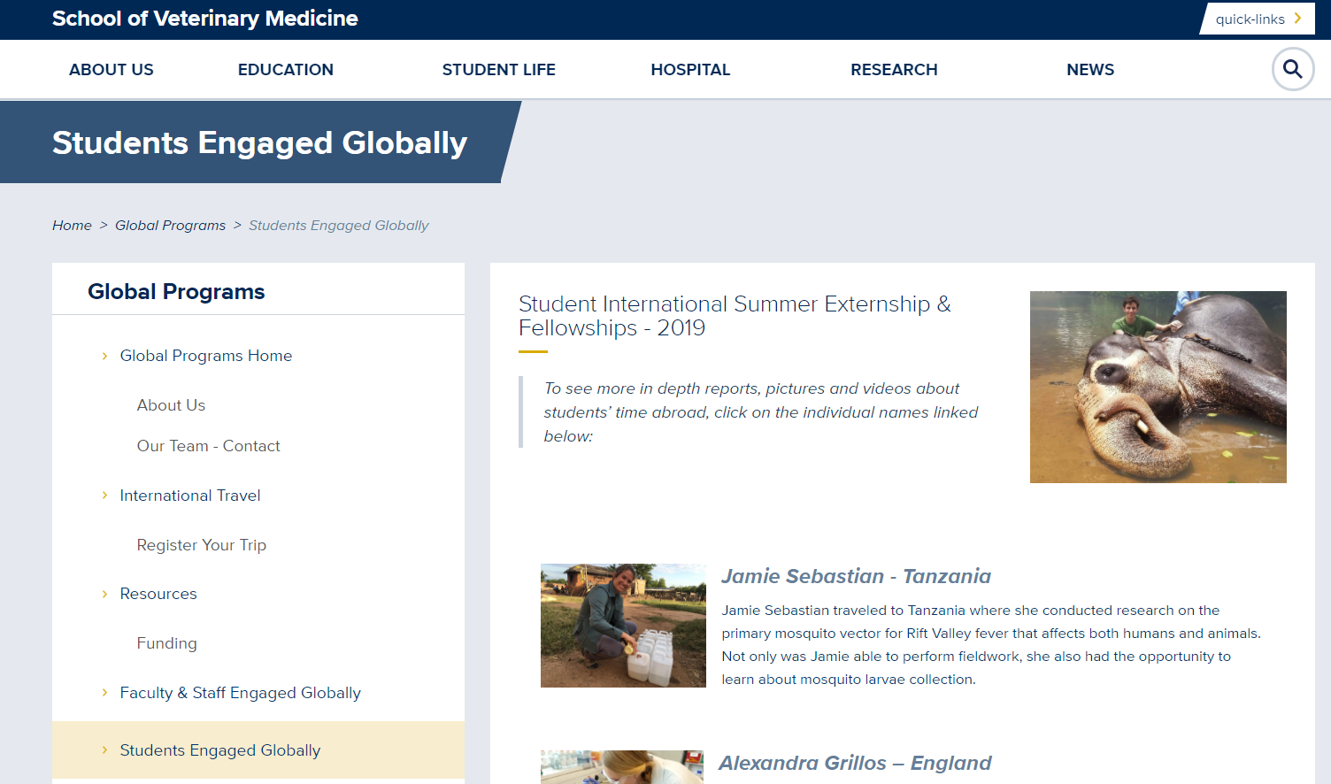

STAR Program and Mentors: You should also investigate the STAR (Students Training in Advanced Research) program and consider applying if you are interested in exploring the possibility of research locally or globally: https://www.vetmed.ucdavis.edu/research/student-research/star. As you are considering mentors for STAR or Global Programs funding, check-out the STAR Mentors webpage. Just click on a topic you are interested in and up will pop several faculty with expertise in those fields and current projects students can work on/research the faculty are doing: https://www.vetmed.ucdavis.edu/research/student-research/star/how-select-mentor

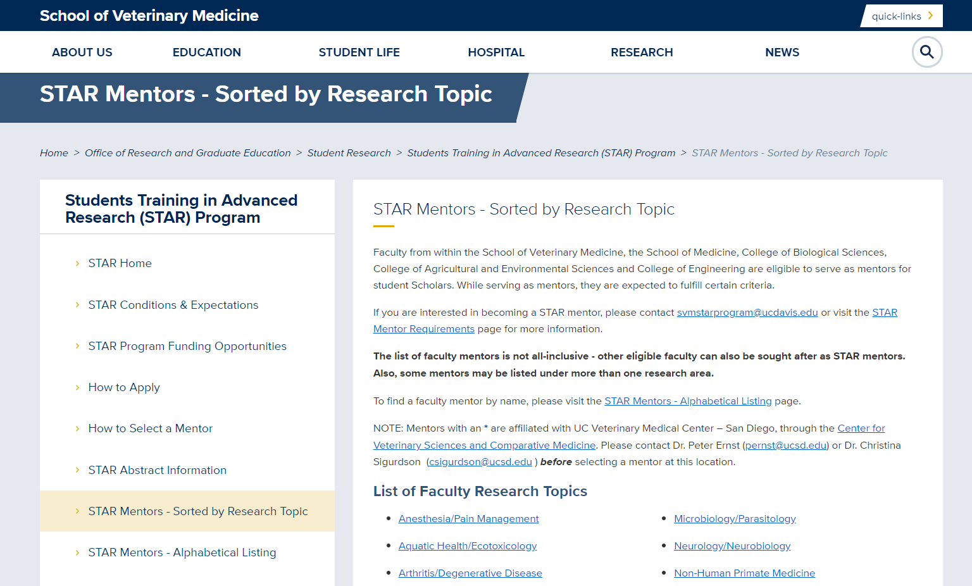

Talk to the Experts
Talking to some experts can be a helpful way to find out about some opportunities you may not have thought of – though we do recommend you try the steps above before doing so. Associate Dean Pat Conrad is happy to meet with you via Zoom and can help to point you in the right direction. Don’t struggle! She can work with you to develop your ideas, find the best potential faculty mentors and make connections. Write to her directly at paconrad@ucdavis.edu, or to Carolyn Forlee at cforlee@ucdavis.edu who can arrange the appointment.

Then What?

Reach out!
Reach out to UC Davis or International mentors to get questions answered and start figuring out possible summer projects and experience. (Dr. Conrad can help you with these contacts as busy people often fail to respond).Then keep an eye out for emails from the Office for Global Programs for when applications are being accepted for International Externship/Global Fellowship funding (and also STAR if you are planning on doing research abroad!). You can view the 2020 guidelines and applications. Likely 2021 will be similar and should be posted by the end of October.

Funding
There are several funding opportunities for international summer experiences. These include:
- Office for Global Programs Funding https://www.vetmed.ucdavis.edu/global-programs/resources/funding
  - International Summer Externship
  - Global Feline Health Fellowship
  - Global Underserved Communities Fellowship
  - Cheetah Conservation Fund Internship
- Office of Research
  - STAR funding for research https://www.vetmed.ucdavis.edu/research/student-research/star
Please be aware that you can apply for ALL of the above funding opportunities, HOWEVER, if you receive funding from both STAR and one of the Fellowships, you may only accept ONE of those funding sources. If you are awarded the International Summer Externship, you may accept that funding no matter what other funding sources you receive.

For example:
Leah Streb applied for funding to conduct an international research project working on Rift Valley fever virus (she did her project before joining the Rx One Health course in Tanzania). She applied for the International Summer Externship ($2500), the Global Underserved Communities Fellowship (~$6,000), and STAR funding (~$6,000). She was selected for all funding sources. However, she had to choose between the Fellowship and STAR as she could only receive one award. She chose the Global Fellowship and was able to receive that funding in addition to the International Summer Externship totaling about $8500.

Created by Leah Streb, Global Health Fellow
Updated by Dr. Conrad, Associate Dean 10/10/2020

