UNIVERSITY OF CALIFORNIA, DAVIS
VETERINARY MEDICAL TEACHING HOSPITAL
PATIENT REFERRAL
Date: ___________________________________________
This will introduce my client: _________________________
Patient name: ____________________________________
Client contact information: __________________________
Referred by Dr.: __________________________________
Clinic name: _____________________________________
Phone: _________________________________________

Please indicate the level of communication you prefer on this case:
Please indicate which Specialty Service you are referring to: __________________________________

- Written case summary is sent to all referring veterinarians within 10 days of discharge.
- Phone call within 24 hours of arrival.
- Phone call when significant event occurs, i.e., a diagnosis is made, patient condition changes, etc.
- Communication by fax is acceptable. My fax number is_______________________________________
- Communication by e-mail is acceptable. My e-mail address is__________________________________

Case history including duration of illness, signs observed, laboratory results, radiographic results (include radiographs), surgical/medical treatment received, immunizations diet, etc.

Suggestions, expectations and comments by Referring Veterinarians:

Please fax this form to: Small Animal Clinic: (530) 752-9620
Large Animal Clinic: (530) 752-9815

Please call the VMTH for an appointment: Small Animal Clinic: (530) 752-1393
Large Animal Clinic: (530) 752-0290

Dear Client,

As you plan your visit to the Veterinary Medical Teaching Hospital (VMTH), please keep these things in mind:
• Plan on spending at least 90 minutes, and up to a full day, if X-rays or other diagnostic tests are to be performed. The VMTH is a teaching hospital. Students, under direct guidance of faculty and resident veterinarians will assist in diagnosing and treating your pet’s problem.
• Costs for services at the VMTH are comparable to those of veterinarians in private practice. You can expect to receive a written estimate and may discuss cost estimates and options available with the VMTH veterinarian in charge of your case.
• Full payment for services is required at the end of your visit. If your animal is admitted for diagnosis or treatment for estimates that exceed $3000, a deposit of 100% of the lower end of the estimate will be expected at the time of admission. The deposit for estimates of $3000 and lower is 50% of the high end of the estimate. The VMTH accepts cash, checks, Visa, MasterCard, Discover, American Express and ATM debit cards.

Directions to the Large Animal Clinic:
Exit from Interstate 80 onto Highway 113-North (Woodland). Take the first exit from 113 to Hutchison Drive and bear right (east) on Hutchison Drive. Take the first right (Health Sciences Drive). At the stop sign turn right on W. Health Sciences Drive. Turn left at the intersection of Garrod Drive and W. Health Sciences Drive. After the stop sign, proceed directly and enter through the gate into the VMTH Large Animal Clinic parking lot.
Directions to the Small Animal Clinic:
Exit from Interstate 80 onto Highway 113-North
(Woodland). Take the first exit (Hutchison Drive) and bear right (east) on Hutchison Drive. Turn right at the first stop light (La Rue Road). Follow La Rue Road to the first right turn (Garrod Drive). Follow Garrod Drive to the stop sign. Turn right on Veterinary Medicine Drive and follow into the Client Parking lot.

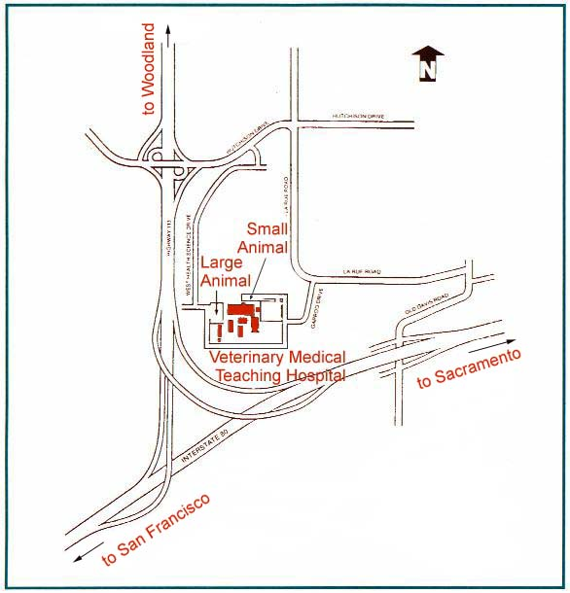
If possible, before coming to the VMTH, we recommend that you visit us online at http://www.vetmed.ucdavis.edu/vmth, where more information on how to prepare for your visit and what to expect when you get here can be found.

